

**AMERICAN INTERNATIONAL UNIVERSITY–BANGLADESH (AIUB)**

**Dept. of Computer Science**

**Faculty of Science and Technology**

**CSC2210: OBJECT ORIENTED PROGRAMMING 2**

**Fall 2024-2025**

**Section: [*H*]**

**Group No: 01**

**Project Report On**

*Project Name [AgriMarket-Pro****]***

**Supervised By**

**TASLIMUR RAHMAN**

**Submitted By:**

|  |  |
| --- | --- |
| **Name** | **ID** |
| **1. SHOWRAV GHOSH** | **23-50666-1** |
| **2. EKRAMUL HASIB** | **23-51106-1** |
| **3. ABDUL ALIM** | **23-51105-1** |
| **4.** **MD. ARIFUL HASSAN COWDURY** | **22-49551-3** |

|  |  |  |  |  |  |  |  |
| --- | --- | --- | --- | --- | --- | --- | --- |
| **Obtained Marks for CO2 and CO3 (Description given in the following page)** | | | | | | | |
| **Assessment Criteria** | **Not Attended/ Incorrect (0)** | | **Inadequate  (1-2)** | | **Average (3)** | **Good  (4)** | **Excellent (5)** |
| **Evaluation Criteria (CO2)** | | **Total =** | | **Evaluation Criteria (CO3)** | | | **Total =** |
| Requirement fulfillment | |  | | Organization of the application | | |  |
| Validation | |  | | Representation and Integration of Database | | |  |
| Verification | |  | | Graphical User Interface | | |  |

|  |  |  |  |  |  |  |  |  |  |
| --- | --- | --- | --- | --- | --- | --- | --- | --- | --- |
| **CO2:** Display and verify the mean of a real-life Project using the concepts of C# Graphical User Interface based environment with database integration to depict a desktop-based application. | | | | | | | | | |
| **Assessment Criteria** | **Not Attended/ Incorrect (0)** | **Inadequate  (1-2)** | | **Average (3)** | | **Good  (4)** | | **Excellent (5)** | |
| **Evaluation Criteria** | **Evaluation Definition** | | | | | | | | |
| Requirement fulfillment | Fails to demonstrate any understanding of real-life scenario-based project development or functional requirement identification. There is no attempt to depict a project or identify functional requirements accurately. | | Demonstrates limited understanding of real-life scenario-based project development and functional requirement identification. The project depicted lacks coherence or relevance to real-life scenarios, and functional requirements are inaccurately identified or insufficiently described. | | Presents a basic depiction of a real-life scenario-based project and identifies some functional requirements. However, the project lacks depth or complexity, and some functional requirements may be vaguely defined or missing key details. | | Effectively demonstrates a realistic scenario-based project and accurately identifies most functional requirements. The project is well-developed with appropriate complexity, and functional requirements are clearly articulated with relevant details. | | Exhibits an exceptional understanding of real-life scenario-based project development and accurately identifies all functional requirements. The project is meticulously developed with thorough attention to detail, reflecting a comprehensive understanding of Object-Oriented Programming project development activities. |
| Validation | Fails to demonstrate any understanding or implementation of validation forms in their system. There is no attempt to deal with data validation, and validation requirements are completely ignored or incorrectly applied. | | Demonstrates limited understanding of validation forms and data validation techniques. While some attempt may be made to implement validation, it is incomplete or poorly executed, leading to inadequate handling of data validation. | | Shows a basic understanding of validation forms and data validation techniques. They attempt to implement validation, but some aspects may be missing or incorrectly implemented, resulting in partial or inconsistent handling of data validation. | | Effectively demonstrates the use of validation forms and implements data validation techniques. Validation is mostly accurate and comprehensive, ensuring the proper handling of data input and verification in the system. | | Exhibits an exceptional understanding and implementation of validation forms and data validation techniques. Validation is meticulously implemented with thorough attention to detail, ensuring robust data validation procedures and contributing to the overall reliability and integrity of the system. |
| Verification | Fails to demonstrate any attempt to verify the system data or functional requirements. There is no evidence of understanding or implementation of verification processes, and data flow is not considered. | | Demonstrates limited understanding of verification processes and data flow in the system. Verification attempts are incomplete or inaccurate, and there is insufficient consideration given to ensuring data integrity and functionality. | | Shows a basic understanding of verification processes and attempts to verify system data. However, verification efforts may be inconsistent or lack thoroughness, and there may be gaps in ensuring proper functional requirements and data flow. | | Identifies and verifies system data, ensuring proper functional requirements are met. Verification efforts are mostly accurate and thorough, with attention to ensuring data integrity and appropriate data flow within the system. | | Exhibits an exceptional understanding of verification processes and meticulously verifies system data. Verification efforts are comprehensive and precise, with a keen focus on ensuring all functional requirements are met and maintaining proper data flow throughout the system. |

|  |  |  |  |  |  |  |  |  |  |
| --- | --- | --- | --- | --- | --- | --- | --- | --- | --- |
| **CO3:** Prepare and Explain a real life desktop based application synthesizing several component of C# along with development tools to adhere the given requirements. | | | | | | | | | |
| **Assessment Criteria** | **Not Attended/ Incorrect (0)** | **Inadequate  (1-2)** | | **Average (3)** | | **Good  (4)** | | **Excellent (5)** | |
| **Evaluation Criteria** | **Evaluation Definition** | | | | | | | | |
| Organization of the application | Fails to identify any suitable real time application or requirements for project development activities related to OOP. | | Limited understanding about the project scopes and scenarios or identification of functional requirements. | | Lacks depth or relevance to OOP project development activities and may contain inaccuracies. Real-life scenarios are mentioned, but the discussion lacks depth or clarity. | | Consider and integrate the idea of several core aspects of the project along with relevance to real-life scenarios. Demonstrating a solid understanding of the application presentation. | | Generalize and exhibits an exceptional understanding of project preparation according to a to real-life scenarios. Also contains proper and insightful identification of the system which is comprehensive and precise. |
| Representation and Integration of Database | Fails to identify and present any understanding or implementation of database. Also failed to integrate the data with the project itself. | | Limited understanding of the database concepts or their proper way of using in a real time project. While some attempt may be made to implement but it is incomplete or poorly executed, leading to inadequate design. | | Lacks depth or relevance to database integration with the application. Shows a basic understanding but some aspects may be missing or incorrectly implemented, resulting in partial or inconsistency. May lack proper normalization. | | Integrate the database with the forms properly and implements it with proper validation which is mostly accurate and comprehensive, ensuring the proper handling of data input and verification along with general normalization. | | Exhibits an exceptional understanding and implementation of database ensuring attention to detail, and robust data manipulation procedures and contributing to the overall clarity. |
| Graphical User Interface | Fails to present or prepare GUI based application interfaces. There is no evidence of creating or integrating such things according to their usefulness. | | Limited understanding of graphical user interfaces. Lack of design knowledge. Very poor attempt to make such things which are currently obsolete or can’t be identified as coherent. | | Shows a basic understanding of creating user interfaces. Most of them are interconnected but maybe some of them lack it. However, most of it can be described as user friendly. | | Effectively identifies and meet the consider the simplicity. Design related works are mostly accurate and taken proper attention to ensuring a user-friendly coherent system. | | Exhibits an exceptional work design following a high standard of simple and elegant work. Several controls and mechanism has been organized in a preferred way according to the coherent usage . |

**Table of Contents: Page no.**

1. Chapter: 01 (Cover Page)------------------------------------------------------------------------ 01

2. Chapter: 02 (Table Of Content)----------------------------------------------------------------- 04

3. Chapter: 03 (Introduction)----------------------------------------------------------------------- 05

4. Chapter: 04 (User Story)------------------------------------------------------------------------- 08

5. Chapter: 05a (ER Diagram)---------------------------------------------------------------------- 11

6. Chapter: 05b (SQL Queries)--------------------------------------------------------------------- 12

7. Chapter: 06 (Screenshots)------------------------------------------------------------------------ 19

**Introduction:**

The **AgriMarket-Pro** is a **desktop-based application** developed to assist administrators in efficiently managing **employees, farmers, users, products, and financial transactions**. The system is designed to provide a structured and **easy-to-use interface** that helps reduce manual work and errors while improving efficiency in handling records.

Many organizations, especially those dealing with **multiple employees and customers**, require an efficient **database management system** that allows them to store and retrieve information quickly. This system **eliminates the need for traditional paperwork** and **manual record-keeping** by providing a digital solution that ensures data is **secure, well-organized, and easily accessible**.

The system includes **user authentication**, allowing only authorized admins to access and manage data. The **dashboard** serves as a central point where admins can navigate different sections like **Employee Management, Farmer Management, User Management, Product Management, and Payment Tracking**.

One of the key features of this system is **payment management**, where admins can track **unpaid users** and manage **financial transactions**. Users can pay through multiple payment methods like **Bkash, Brac Bank, and City Bank**, and all transactions are recorded in the database. The system also has a **search and filtering option** that allows admins to **find records instantly**.

Additionally, the system ensures **data security** by allowing **deleted records to be restored** instead of being permanently erased. If an admin mistakenly removes an **employee, farmer, or user**, they can **recover the data from the deleted list**.

With a **user-friendly graphical interface (GUI)** built using **Windows Forms (WinForms) and C#**, and **a strong database foundation using Microsoft SQL Server**, this system provides an **efficient, reliable, and secure** way to manage organizational records.

**Objectives:**

The main goals of this **AgriMarket-Pro** are:

✅ **Streamline Administration** – Reduce manual record-keeping by providing a **centralized digital platform** for managing employees, farmers, and users.  
✅ **Ensure Data Security** – Prevent **unauthorized access** with a **secure login system** and **store records safely** in a SQL database.  
✅ **Simplify Employee and Farmer Management** – Allow admins to **add, edit, delete, and search** records quickly.  
✅ **Enable Payment Tracking** – Keep a **record of pending payments** and allow users to **pay using multiple methods**.  
✅ **Improve Data Retrieval** – Provide **fast searching and filtering** features to find information instantly.  
✅ **Allow Restoration of Deleted Records** – Ensure that accidentally deleted employees, farmers, or users **can be restored easily**.  
✅ **User-Friendly Interface** – Develop a **clean and simple UI** that is **easy to navigate** for admins.

**Technical Stack:**

This system is built using **modern and efficient technologies** to ensure smooth operation:

🔹 **Programming Language:** C# (.NET Framework) – Used to develop the core functionality of the system.  
🔹 **User Interface:** Windows Forms (WinForms) – A **graphical user interface (GUI)** for a smooth user experience.  
🔹 **Database:** Microsoft SQL Server (LocalDB) – Stores all records securely and allows **quick retrieval of data**.  
🔹 **Development Environment:** Visual Studio – Provides an **integrated development environment (IDE)** for writing, debugging, and testing the application.  
🔹 **Database Connectivity:** ADO.NET – Used to connect **C# with the SQL Server database**.

**Features:**

The **AgriMarket-Pro** is packed with **powerful features** that help administrators manage data **efficiently and securely**:

**1️. Admin Dashboard**

* Provides a **centralized control panel** where admins can access all features.
* Quick navigation to **Employee, Farmer, User, Product, and Payment sections**.

**2️. Secure Login System**

* **Ensures only authorized admins** can access the system.
* Prevents **unauthorized modifications or data leaks**.

**3️. Employee Management**

* **Add new employees** to the database with details like **name, salary, phone number, and gender**.
* **Update employee records** when needed.
* **Delete employees** (deleted records can be restored later).
* **Search employees** by name or phone number for quick access.

**4️. Farmer Management**

* Register and **manage farmers** in the system.
* Store **farmer details** including **name, birth date, address, phone number, and gender**.
* **Search and filter farmers** based on their details.
* **Restore deleted farmers** from the deleted list.

**5️. User Management**

* Register and manage **users/customers** in the system.
* Maintain records of **contact information, addresses, and transactions**.
* Allow **searching for users by name or phone number**.
* **Restore deleted users** if needed.

**6️. Payment Management**

* View a **list of unpaid users** and track outstanding payments.
* Allow users to **make payments through different methods** (Bkash, Brac Bank, City Bank).
* Record **transaction history** in the database for future reference.
* Generate **real-time payment reports**.

**7️. Product Management**

* Maintain a **list of products** for business operations.
* Track **product name, quantity, and price**.
* View **all available and sold products**.

**8️. Search and Filtering**

* **Quickly find employees, farmers, and users** using search and filtering options.
* **Reduce time spent on searching records** by applying specific filters.

**9️. Restore Deleted Records**

* If an admin **accidentally deletes an employee, farmer, or user**, the system allows them to **restore the record**.
* Ensures **data is not permanently lost**.

**10. Database Connectivity**

* **All data is stored securely in SQL Server**, ensuring it is not lost in case of system failure.
* The system **automatically retrieves and updates** records in the database when changes are made.

**How It Works:**

**1. Admin Login**

Admins enter **login credentials** to access the system. Only **authorized users** can enter.

**2. Managing Employees, Farmers, and Users**

* Admins can **add new records**.
* They can **search, update, and delete** records.
* Deleted records are **stored separately** for recovery if needed.

**3. Payment Tracking**

* The system shows a **list of unpaid users**.
* Users can **make payments using different methods**.
* Transactions are **automatically recorded in the database**.

**4. Product Management**

* Admins can **view and manage products**.
* The system keeps track of **available and sold products**.

**5. Searching and Filtering**

Admins can quickly find **specific records** without having to manually scroll through lists.

**6. Restoring Deleted Records**

If a **record is deleted by mistake**, it can be **restored from the deleted list**.

**Conclusion:**

The **AgriMarket-Pro System** is a **powerful tool** that helps organizations manage **employees, farmers, users, products, and payments** with ease. It **saves time, reduces errors, and ensures data security** by storing information in a **well-organized database**.

By automating **record management and payment tracking**, this system significantly **improves efficiency** and allows admins to focus on **business operations instead of manual paperwork**.

With features like **secure login, search filters, database integration, and record restoration**, this system is **an ideal solution for businesses that require an organized and secure way to manage their administrative tasks**.

**USER STORY**

**Introduction:**

This case study describes an entity-relationship (ER) diagram that represents a system where farmers, users, and admins interact with products, payments, and accounts. The system helps in managing transactions between different entities in an organized way.

**Entities and Attributes:**

**Admin**

* **Admin_ID** (Primary Key)
* Name
* Email
* Phone_Number
* Password
* Gender

**Employee**

* **Employee_ID** (Primary Key)
* Name
* Salary
* Phone_Number
* Gender

**Farmer**

* **Farmer_ID** (Primary Key)
* Name
* Birth_Date
* Address
* Division
* Postal_Code
* Phone_Number
* Email
* Gender
* Password

**User (Customer)**

* **User_ID** (Primary Key)
* Name
* Birth_Date
* Address
* Division
* Postal_Code
* Phone_Number
* Email
* Gender
* Password

**Product**

* **Product_ID** (Primary Key)
* Product_Name
* Product_Quantity
* Product_Price

**Payment**

* **Payment_ID** (Primary Key)
* User_ID (Foreign Key)
* Payment_Method (Bkash, Brac Bank, City Bank, etc.)
* Payment_Status (Paid/Unpaid)
* Amount
* Transaction_Date

**Deleted_Records (for restoring data)**

* **Record_ID** (Primary Key)
* Table_Name (Employee, Farmer, User)
* Deleted_Data (JSON format or separate columns for each field)
* Deletion_Date

**Entities and Their Roles:**

1. **Farmer**
   * Farmers are individuals who sell products like fruits, fish, and vegetables.
   * They have attributes like Name, Address, Gender, Division, Postal Code, Phone Number, and Email.
   * Each farmer has an ID (Far_Id) and a Password for security.
2. **User**
   * Users are buyers who purchase products from Admin.
   * They have similar attributes to farmers: Name, Address, Gender, Division, Postal Code, Phone Number, Email, and Birthdate.
   * Each user has a unique ID (U_Id) and a Password.
3. **Admin**
   * The Admin manages the system and has control over accounts.
   * Admins have an Admin ID (Ad_Id), Name, Email, Password, and Gender.
   * They also have a Phone Number.
4. **Employee**
   * Employees manage different tasks within the system.
   * They have an Employee ID (Emp_Id), Name, Salary, and Gender.
   * They also have a Phone Number.
5. **Product**
   * Products are the items sold by farmers to Admin
   * Each product has a unique Serial Number.
   * Products include items like Hilsa, Papaya, and Apple.
   * Other attributes include Product Name, Product Quantity, Product Price, and Total Price.
6. **Account**
   * Each entity has an account for managing financial transactions.
   * Admins and Employees have accounts to track salaries and payments.
7. **Paid and Unpaid Transactions**
   * When a user purchases a product, the payment status can be either Paid or Unpaid.
   * Unpaid transactions contain details like Phone Number and Total Amount.
   * Paid transactions include details like Serial Number and Payment Amount.
8. **Payment System**
   * The system allows payments through different banks and mobile banking services.
   * Supported services include Brac Bank, City Bank, Rocket, Nagad, and Bkash.
   * Payment details include Serial Number, Phone Number, User ID, and Account Number.

**Relationships in the System:**

1. **Farmers can Sell Products**
   * Farmers can list their products for sale in the system.
   * Each product has a unique Serial Number and details like Product Name, Quantity, and Price.
2. **Users can Buy Products**
   * Users can purchase products from Admin.
   * Each purchase transaction is linked to an account.
3. **Admins Manage the System**
   * Admins oversee Farmers, Users, Employee and accounts.
   * They also handle payments and ensure that transactions are recorded properly.
   * Admin ensures that payments are processed correctly.
   * They track Paid and Unpaid transactions.

**Conclusion:**

This ER diagram represents a well-structured system for managing agricultural product sales and payments. It efficiently connects farmers, users, admins, and employees, ensuring smooth transactions and account management. The system supports secure payments and helps maintain financial records effectively.

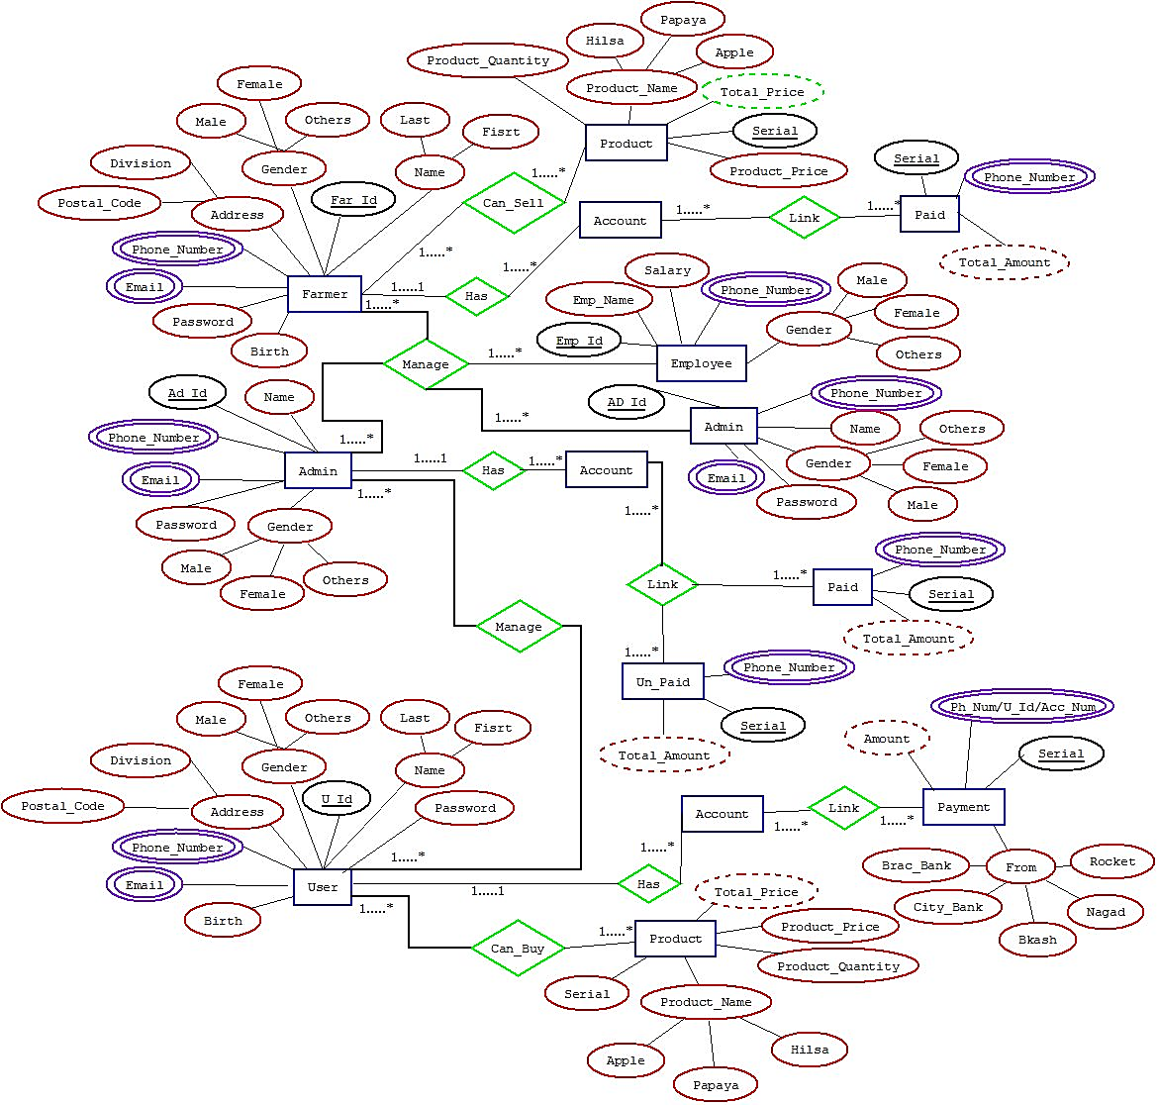**ER Diagram**

**SQL Queries**

**Admin Table:**

CREATE TABLE [dbo].[Admin] (

[Id] INT IDENTITY (1, 1) NOT NULL,

[Name] VARCHAR (50) NOT NULL,

[Phone Number] VARCHAR (50) NOT NULL,

[Email Address] VARCHAR (50) NOT NULL,

[Password] VARCHAR (50) NOT NULL,

[Gender] VARCHAR (50) NOT NULL,

PRIMARY KEY CLUSTERED ([Id] ASC)

);

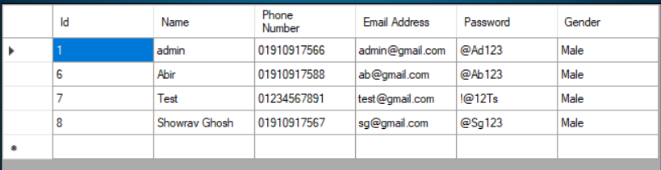

**Delate Admin Table:**

CREATE TABLE [dbo].[Dela] (

[Id] INT IDENTITY (1, 1) NOT NULL,

[Name] VARCHAR (50) NOT NULL,

[Phone Number] VARCHAR (50) NOT NULL,

[Email Address] VARCHAR (50) NOT NULL,

[Password] VARCHAR (50) NULL,

[Gender] VARCHAR (50) NULL,

PRIMARY KEY CLUSTERED ([Id] ASC)

);

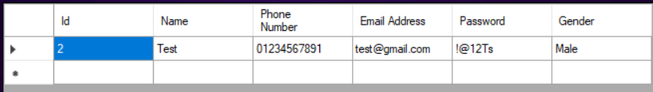

**Employee Table:**

CREATE TABLE [dbo].[Employee List] (

[Id] INT IDENTITY (1, 1) NOT NULL,

[Employee Name] VARCHAR (50) NOT NULL,

[Salary] VARCHAR (50) NOT NULL,

[Phone Number] VARCHAR (50) NOT NULL,

[Gender] VARCHAR (50) NOT NULL,

PRIMARY KEY CLUSTERED ([Id] ASC)

);

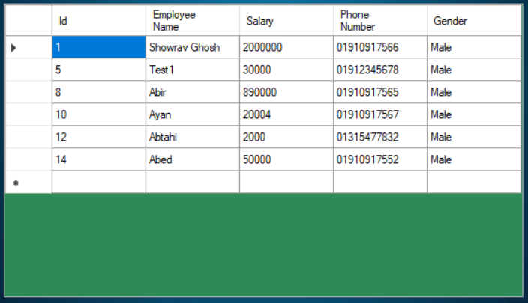

**Delete Employee Table:**

CREATE TABLE [dbo].[DelEmp] (

[Id] INT IDENTITY (1, 1) NOT NULL,

[Employee Name] VARCHAR (50) NOT NULL,

[Salary] VARCHAR (50) NOT NULL,

[Phone Number] VARCHAR (50) NOT NULL,

[Gender] NCHAR (10) NOT NULL,

PRIMARY KEY CLUSTERED ([Id] ASC)

);

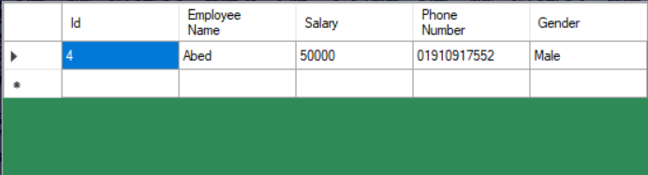

**Farmer Table:**

CREATE TABLE [dbo].[Farmer] (

[Id] INT IDENTITY (1, 1) NOT NULL,

[Name] VARCHAR (50) NOT NULL,

[Birth] VARCHAR (50) NOT NULL,

[Address] VARCHAR (50) NOT NULL,

[Division] VARCHAR (50) NOT NULL,

[Postal Code] INT NOT NULL,

[Phone Number] VARCHAR (50) NOT NULL,

[Email] VARCHAR (50) NOT NULL,

[Gender] VARCHAR (50) NOT NULL,

[Password] VARCHAR (50) NOT NULL,

PRIMARY KEY CLUSTERED ([Id] ASC)

);

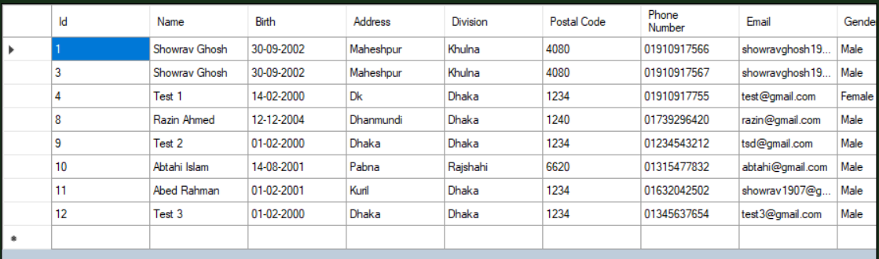

**Delete Farmer Table:**

CREATE TABLE [dbo].[Delf] (

[Id] INT IDENTITY (1, 2) NOT NULL,

[Name] VARCHAR (50) NOT NULL,

[Birth] VARCHAR (50) NOT NULL,

[Address] VARCHAR (50) NOT NULL,

[Division] VARCHAR (50) NOT NULL,

[Postal Code] INT NOT NULL,

[Phone Number] VARCHAR (50) NOT NULL,

[Email] VARCHAR (50) NOT NULL,

[Gender] VARCHAR (50) NOT NULL,

[Password] VARCHAR (50) NOT NULL,

PRIMARY KEY CLUSTERED ([Id] ASC)

);

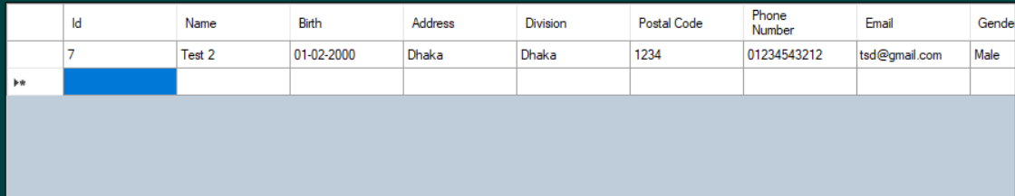

**User Table:**

CREATE TABLE [dbo].[UserList] (

[Id] INT IDENTITY (1, 1) NOT NULL,

[Name] VARCHAR (50) NOT NULL,

[Birth] VARCHAR (50) NOT NULL,

[Address] VARCHAR (50) NOT NULL,

[Division] VARCHAR (50) NOT NULL,

[Postal Code] INT NOT NULL,

[Phone Number] VARCHAR (50) NOT NULL,

[Email] VARCHAR (50) NOT NULL,

[Gender] VARCHAR (50) NOT NULL,

[Password] VARCHAR (50) NOT NULL,

PRIMARY KEY CLUSTERED ([Id] ASC)

);

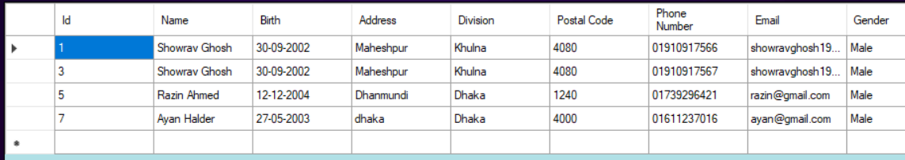

**Delete User Table:**

CREATE TABLE [dbo].[Delu] (

[Id] INT IDENTITY (1, 1) NOT NULL,

[Name] VARCHAR (50) NOT NULL,

[Birth] VARCHAR (50) NOT NULL,

[Address] VARCHAR (50) NOT NULL,

[Division] VARCHAR (50) NOT NULL,

[Postal Code] INT NOT NULL,

[Phone Number] VARCHAR (50) NOT NULL,

[Email] VARCHAR (50) NOT NULL,

[Gender] VARCHAR (50) NOT NULL,

[Password] VARCHAR (50) NULL,

PRIMARY KEY CLUSTERED ([Id] ASC)

);



**Fish Product For Farmer Table:**

CREATE TABLE [dbo].[Fish] (

[Serial] INT IDENTITY (1, 1) NOT NULL,

[Product Name] VARCHAR (50) NOT NULL,

[Product Quantity] VARCHAR (50) NOT NULL,

[Product Price] VARCHAR (50) NOT NULL,

[Total Price] VARCHAR (50) NOT NULL,

PRIMARY KEY CLUSTERED ([Serial] ASC)

);

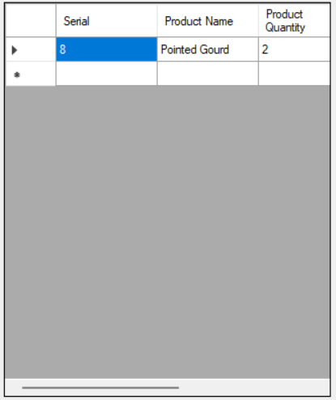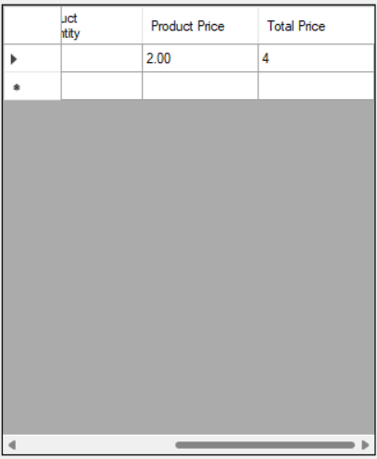

**Fruit Product For Farmer Table:**

CREATE TABLE [dbo].[Fruit] (

[Serial] INT IDENTITY (1, 1) NOT NULL,

[Product Name] VARCHAR (50) NOT NULL,

[Product quantity] VARCHAR (50) NOT NULL,

[Product Price] VARCHAR (50) NOT NULL,

[Total Price] VARCHAR (50) NOT NULL,

PRIMARY KEY CLUSTERED ([Serial] ASC)

);



**Vegetable Product For Farmer Table:**

CREATE TABLE [dbo].[Vegetable] (

[Serial] INT IDENTITY (1, 1) NOT NULL,

[Product Name] VARCHAR (50) NOT NULL,

[Product Quantity] VARCHAR (50) NOT NULL,

[Product Price] VARCHAR (50) NOT NULL,

[Total Price] VARCHAR (50) NOT NULL,

PRIMARY KEY CLUSTERED ([Serial] ASC)

);

 

**Fish Product For User Table:**

CREATE TABLE [dbo].[UFish] (

[Serial] INT IDENTITY (1, 1) NOT NULL,

[Product Name] VARCHAR (50) NOT NULL,

[Product Quantity] VARCHAR (50) NOT NULL,

[Product Price] VARCHAR (50) NOT NULL,

[Total Price] VARCHAR (50) NOT NULL,

PRIMARY KEY CLUSTERED ([Serial] ASC)

);



**Fruit Product For User Table:**

CREATE TABLE [dbo].[UFruit] (

[Serial] INT IDENTITY (1, 1) NOT NULL,

[Product Name] VARCHAR (50) NOT NULL,

[Product Quantity] VARCHAR (50) NOT NULL,

[Product Price] VARCHAR (50) NOT NULL,

[Total Price] VARCHAR (50) NOT NULL,

PRIMARY KEY CLUSTERED ([Serial] ASC)

);



**Vegetable Product For User Table:**

CREATE TABLE [dbo].[UVegetabl] (

[Serial] INT IDENTITY (1, 1) NOT NULL,

[Product Name] VARCHAR (50) NOT NULL,

[Product Quantity] VARCHAR (50) NOT NULL,

[Product Price] VARCHAR (50) NOT NULL,

[Total Price] VARCHAR (50) NOT NULL,

PRIMARY KEY CLUSTERED ([Serial] ASC)

);



**Transaction After Payment Req-Farmer Table:**

CREATE TABLE [dbo].[Paid] (

[Serial] INT IDENTITY (1, 1) NOT NULL,

[Phone Number] VARCHAR (50) NOT NULL,

[Total Amount] VARCHAR (50) NOT NULL,

PRIMARY KEY CLUSTERED ([Serial] ASC)

);

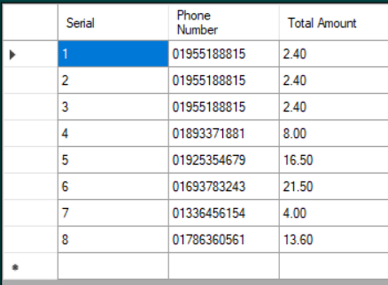

**Transaction After Payment Done For Farmer Payment Request Table:**

CREATE TABLE [dbo].[Unpaid] (

[Serial] INT IDENTITY (1, 1) NOT NULL,

[Phone Number] VARCHAR (50) NULL,

[Total Amount] VARCHAR (50) NULL,

PRIMARY KEY CLUSTERED ([Serial] ASC)

);

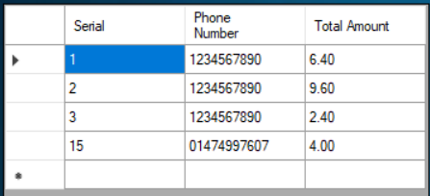

**Transaction After Payment Done Uer Table:**

CREATE TABLE [dbo].[Upaid] (

[Serial] INT IDENTITY (1, 1) NOT NULL,

[Ph_Num/U_ID/Acc_Num] VARCHAR (50) NULL,

[Amount] VARCHAR (50) NULL,

[From] NCHAR (10) NULL,

PRIMARY KEY CLUSTERED ([Serial] ASC)

);

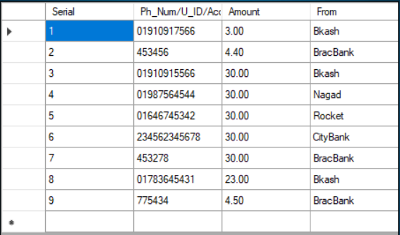

**Screenshots:**

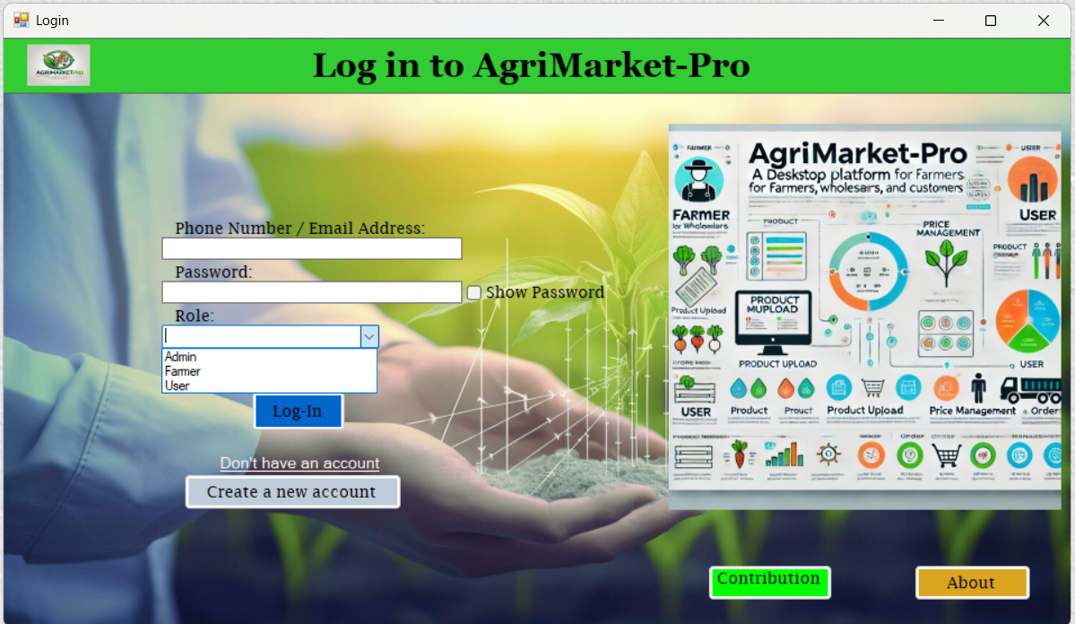

For view password.

Description about this project

See those who have done this project.

For different login page, (Farmer, User, Admin frame)

For Create New account (for new Farmer and User)

After fillup all correctly and click Login,then it help for go to Admin,Farmer,User frame

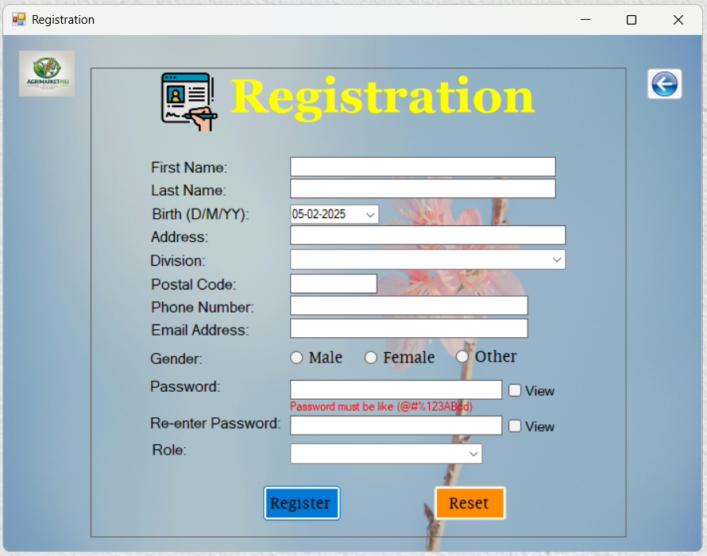

Select Role (Farmer or User) From this ComboBox.

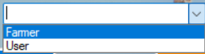

Back Previous Frame.

For select DOB from this ComboBox.

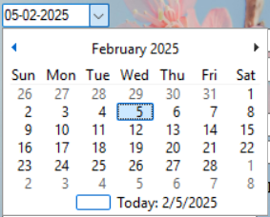

For select Division from this comboBox

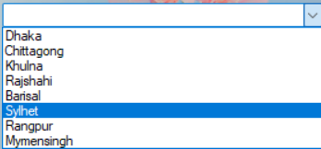

After type all data and then click Register for new account

For Remove all Text and selected field.

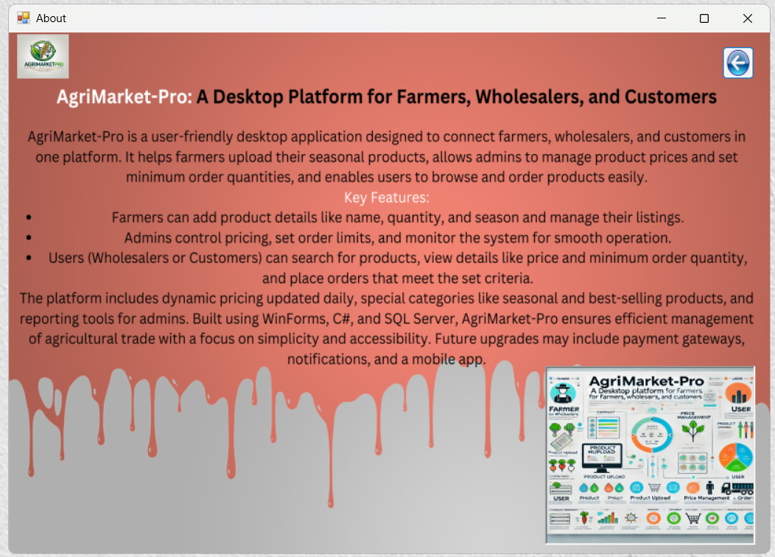

Back Previous Frame.

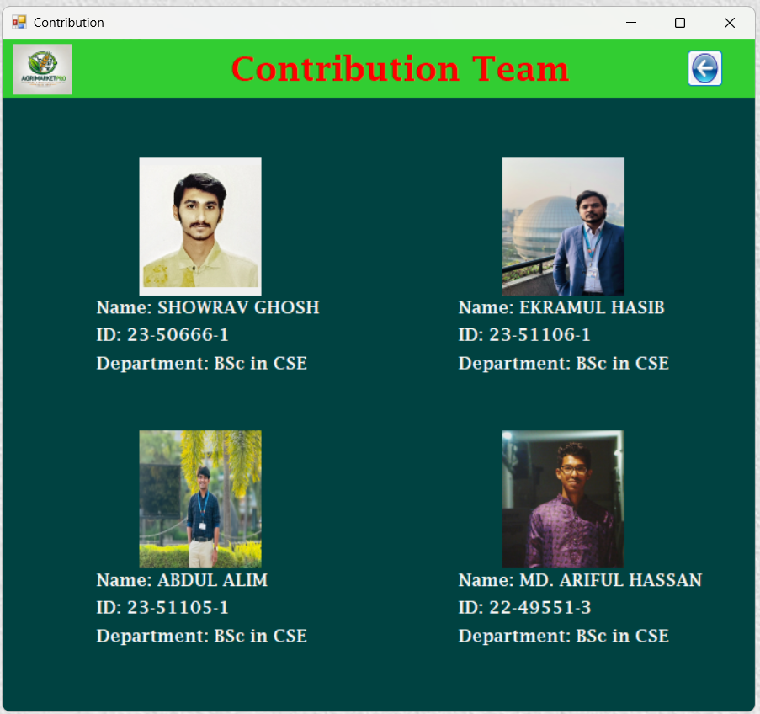

Back Previous Frame.



For Sell Fruits items.

For Sell Fish items.

Foe Sell Vegetable items.

Go for Log-in Frame

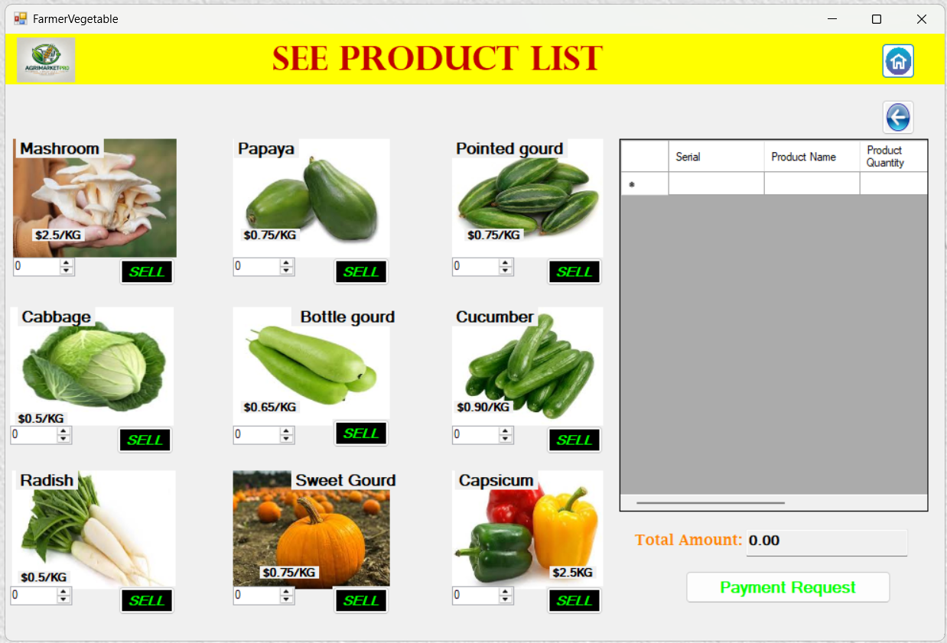

Table for show selected items.

Go for Previous frame.

Go for Log-in Frame

Add product inside the table for sell.

Request send to Admin for payment.

Foe increases and decrease product quantity

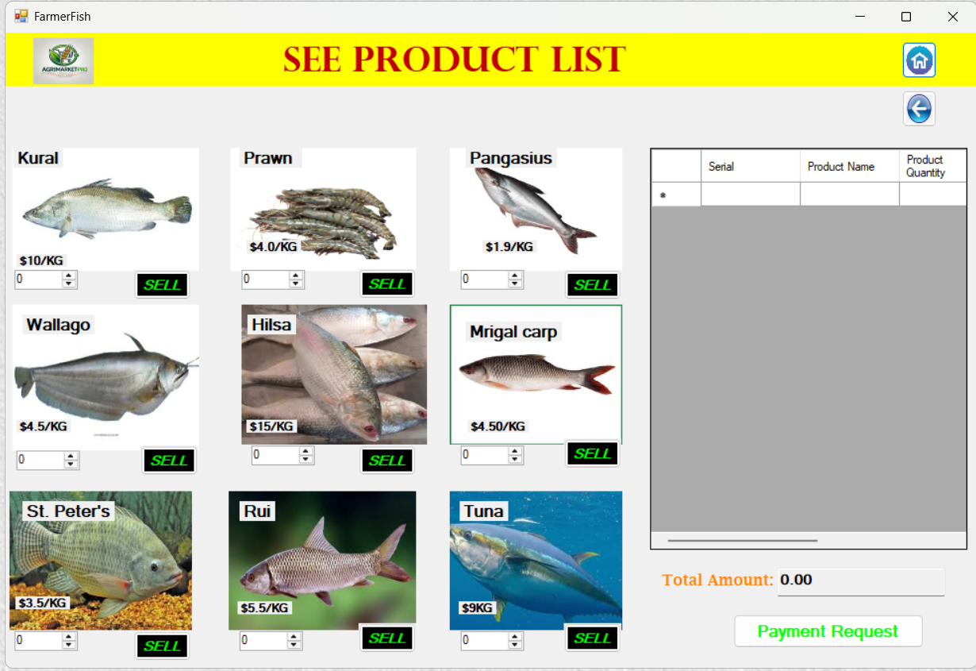

Add product inside the table for sell.

Table for show selected items.

Foe increases and decrease product quantity

Request send to Admin for payment.

Go for Previous frame.

Go for Log-in Frame

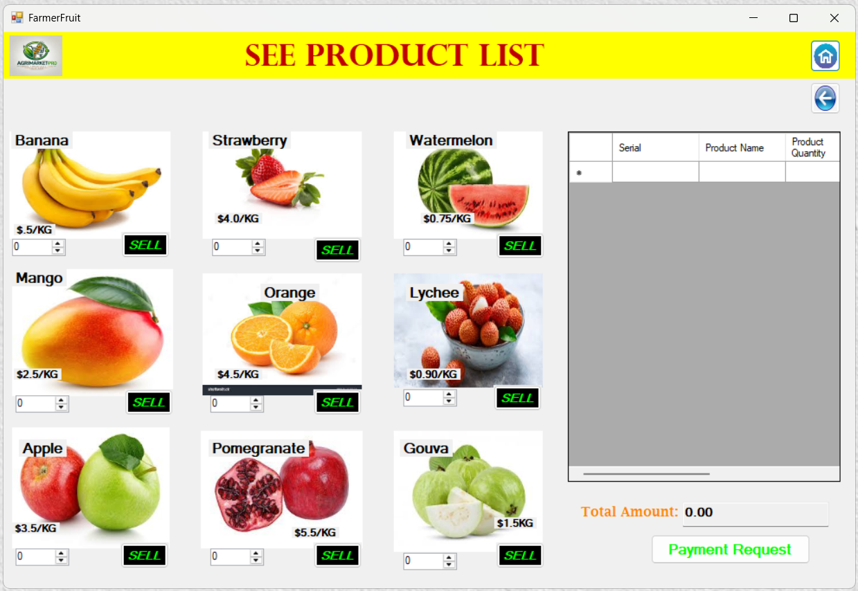

Go for Log-in Frame

Go for Previous frame.

Table for show selected items.

Table for show selected items.

Add product inside the table for sell.

Foe increases and decrease product quantity

Request send to Admin for payment.



For Buy Vegetable items.

For Buy Fish items.

For Buy Fruits items.

Go for Log-in Frame

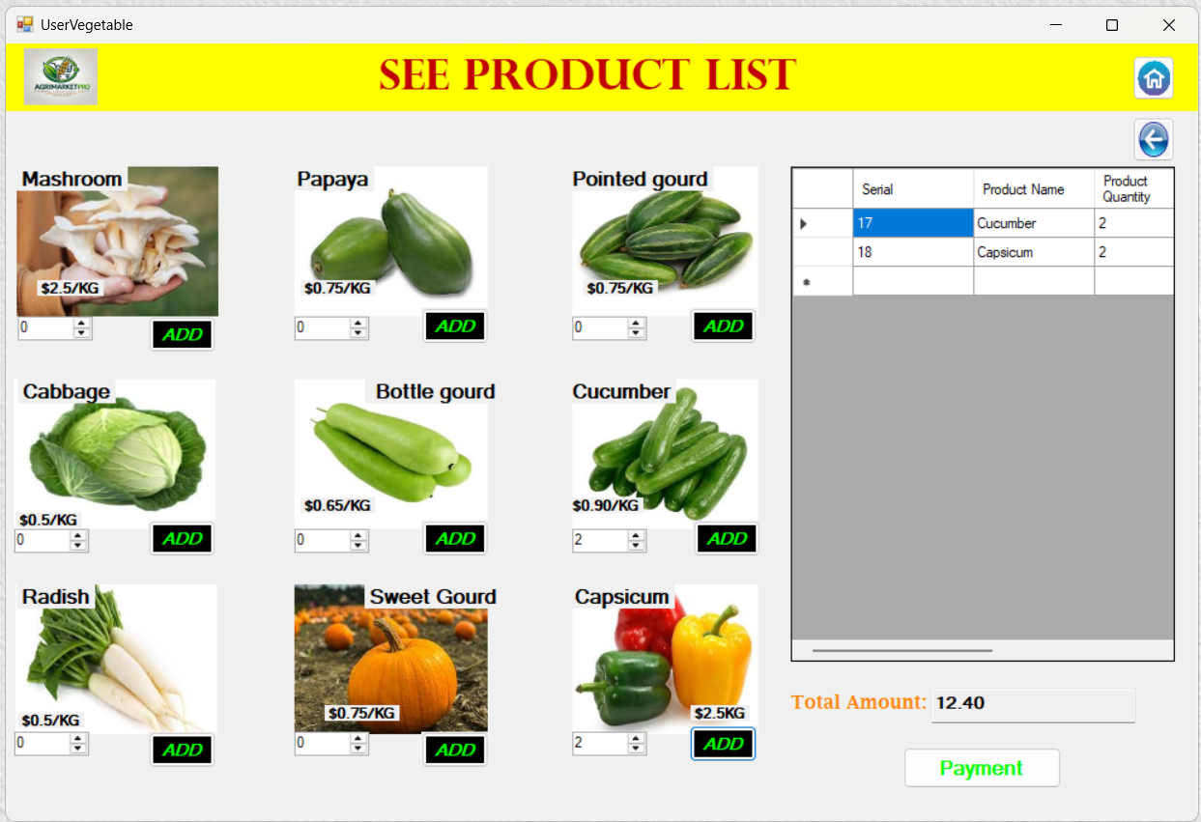

Foe increases and decrease product quantity

Add product inside the table for buy.

Go for Log-in Frame

Go for Previous frame.

Table for show selected items.

Make Payment for selected product.

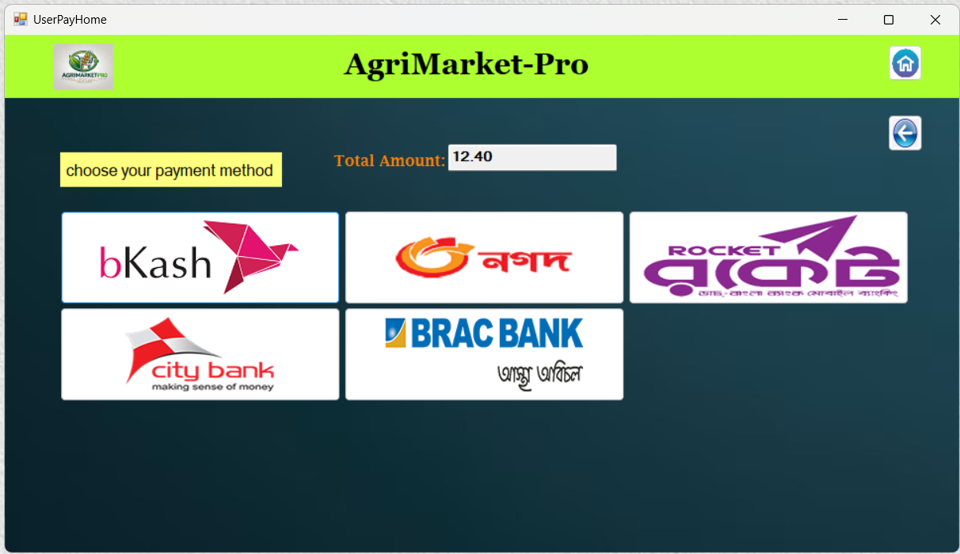

Payment through Banking system

Payment through Mobile banking.

Go for Previous frame.

Go for Log-in Frame

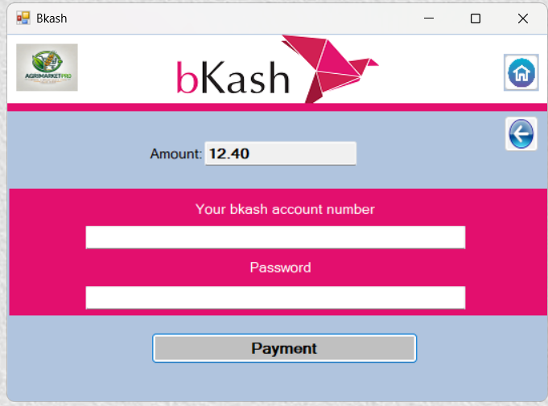

Go for Previous frame.

Go for Log-in Frame

Payment through Bkash.

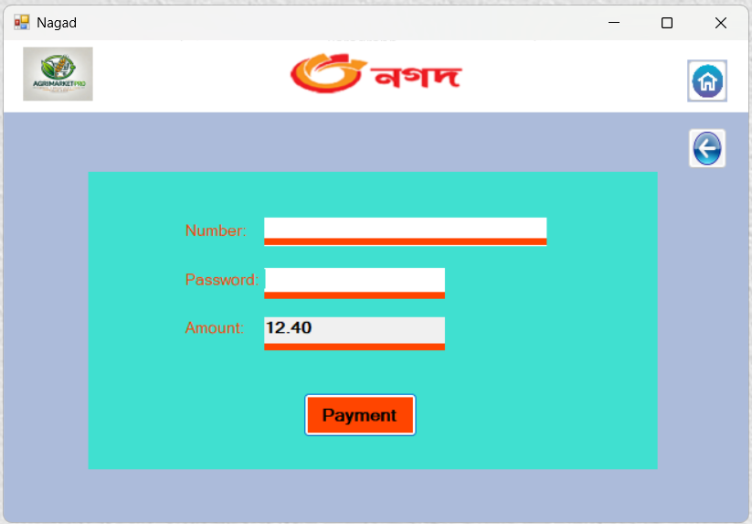

Go for Log-in Frame

Go for Previous frame.

Payment through Nagad.

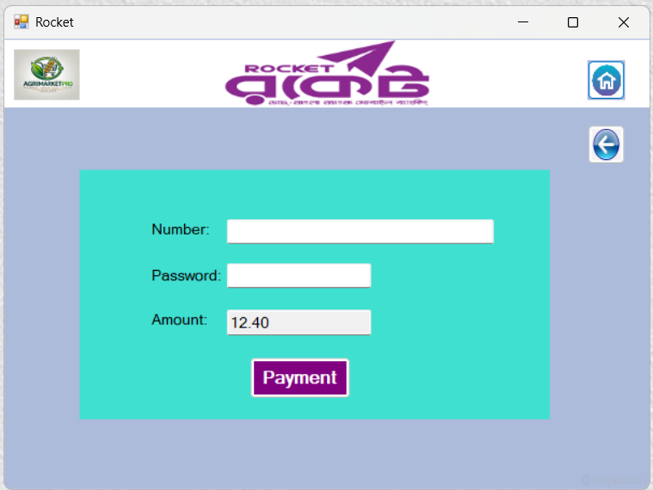

Payment through Rocket.

Go for Previous frame.

Go for Log-in Frame

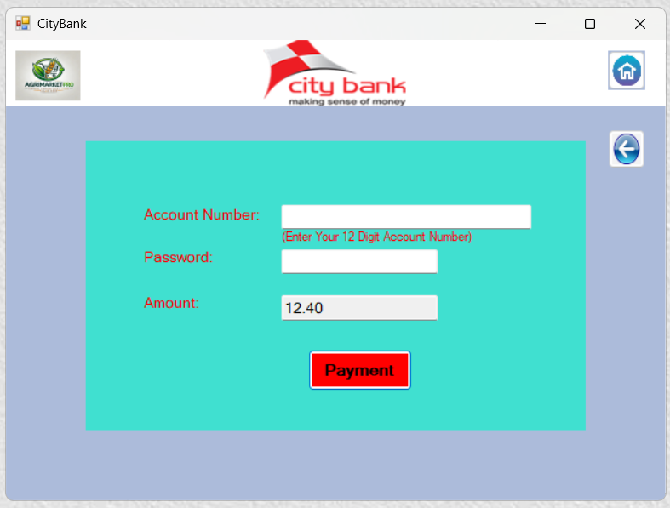

Go for Log-in Frame

Go for Previous frame.

Payment through City-Bank.

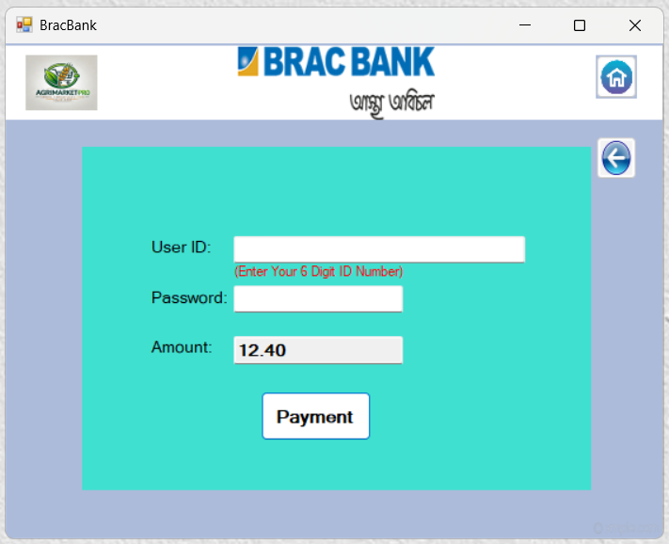

Go for Log-in Frame

Go for Previous frame.

Payment through Brac-Bank.

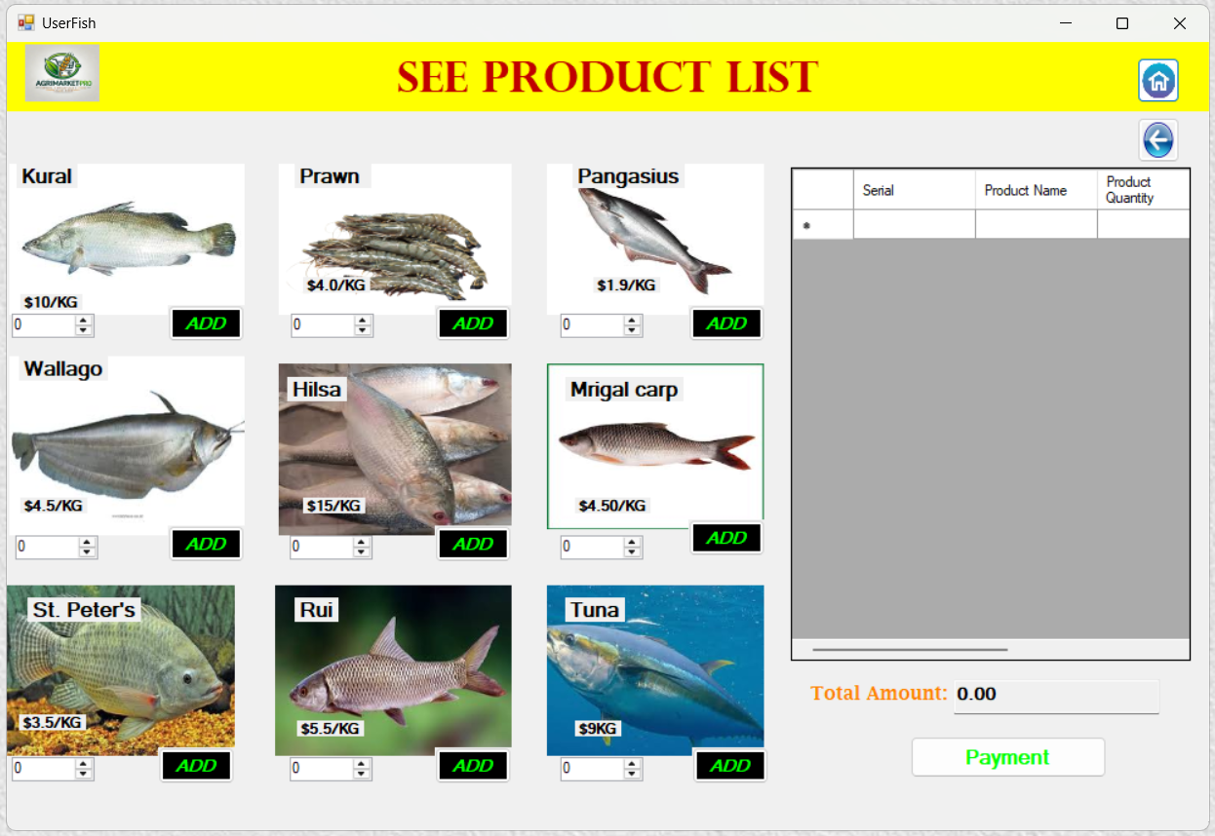

Make Payment for selected product.

Add product inside the table for Buy

Foe increases and decrease product quantity

Go for Log-in Frame

Go for Previous frame.

Table for show selected items.

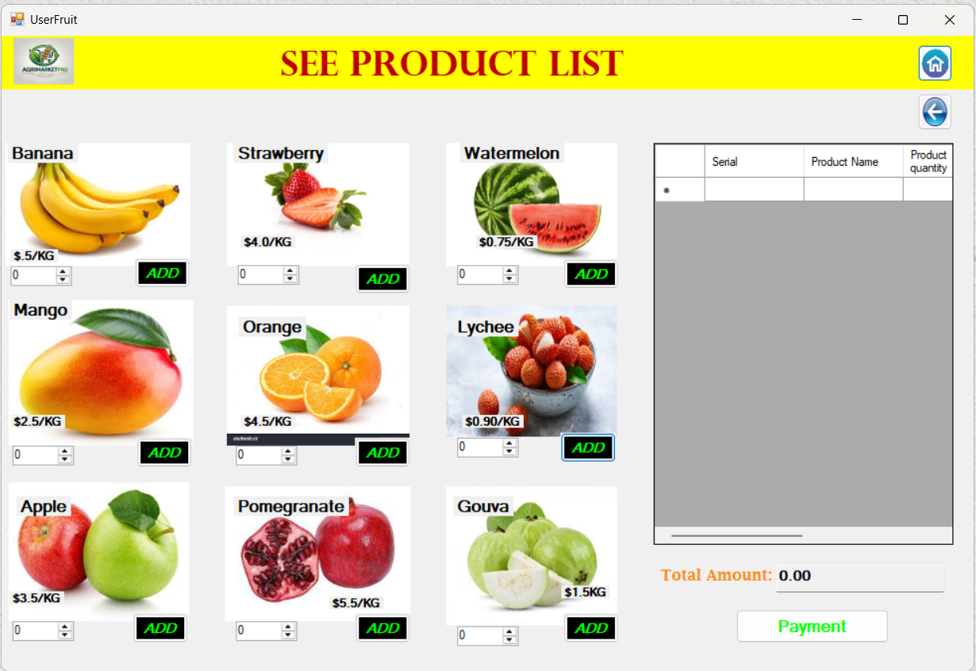

Go for Log-in Frame

Add product inside the table for Bye.

Foe increases and decrease product quantity

Go for Previous frame.

Table for show selected items.

Make Payment for selected product.

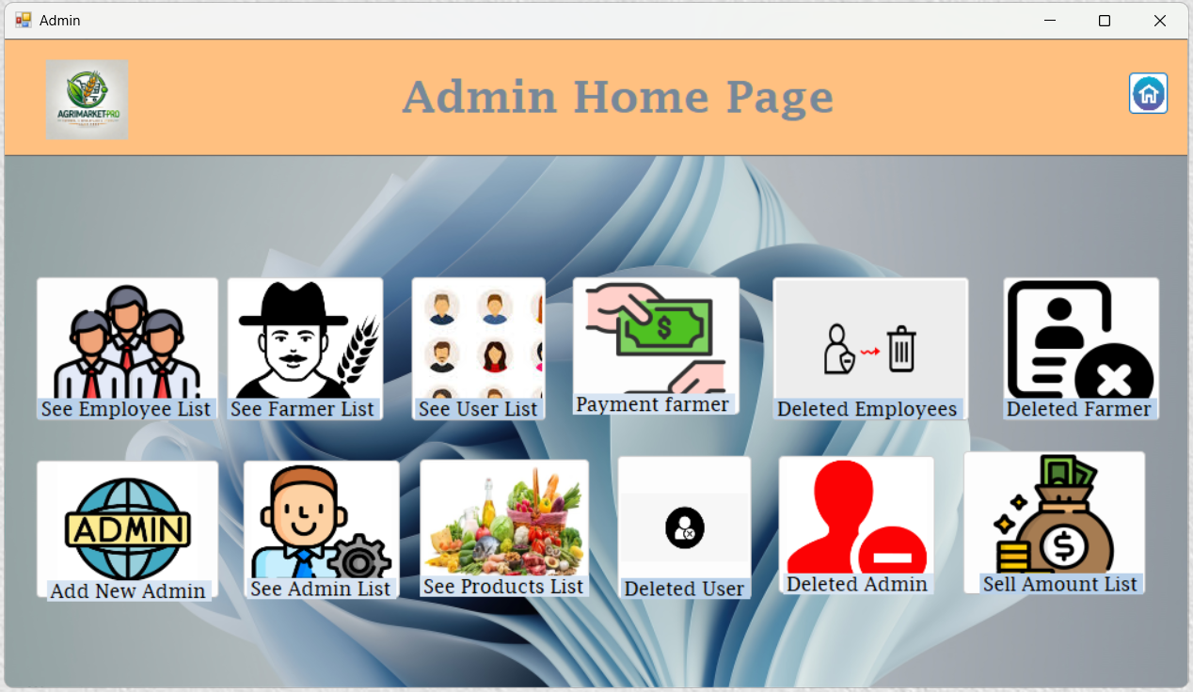

Go for Log-in Frame

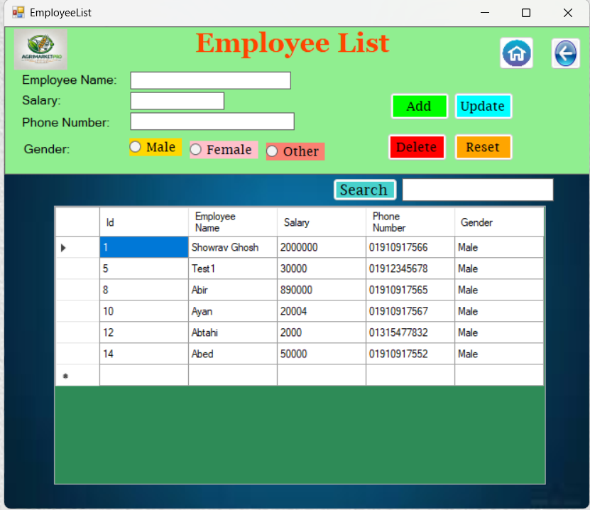

Update data from inside the table.

Remove all selected things.

For delete admin from list.

For add new Employee

Go for Log-in Frame

Go previous page.

Search employee by their name or phone number.

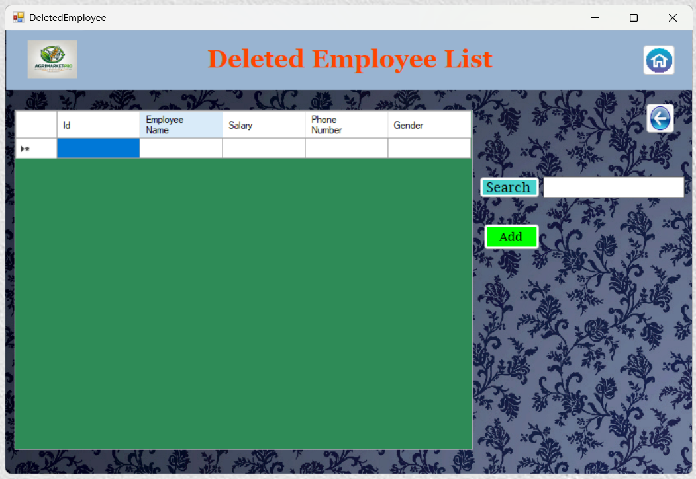

For Add again employee in the employee list table.

Search deleted employee from the table.

Go previous frame.

Go for Log-in Frame

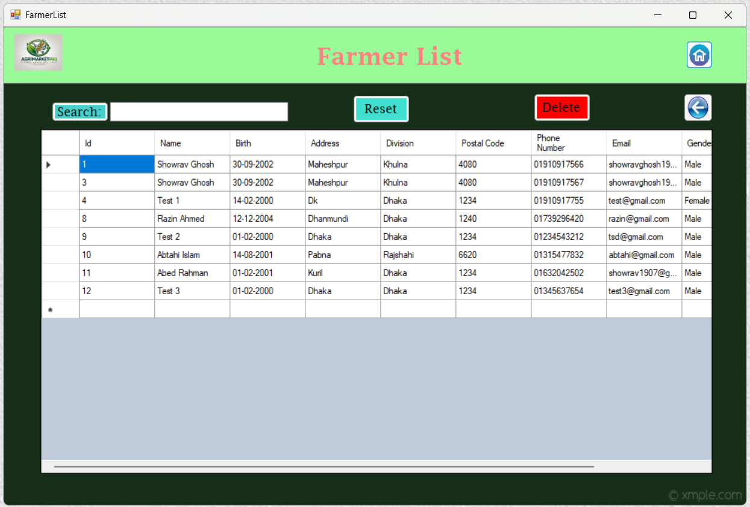

Delete Farmer from the list.

Go previous frame

Go for Log-in Frame

Type name or number for search

Blank search box

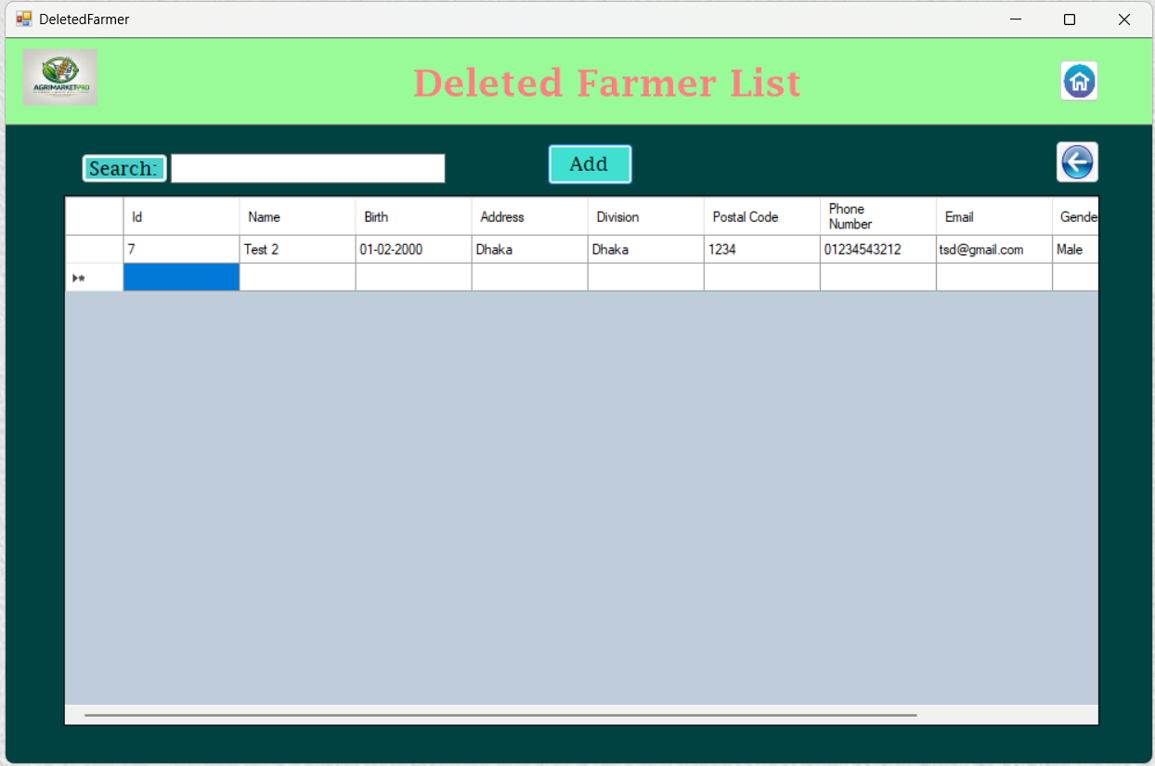

For search deleted farmer from the table.

Add again in the Farmer list table from this

Table.

Back previous frame

Go for Log-in Frame

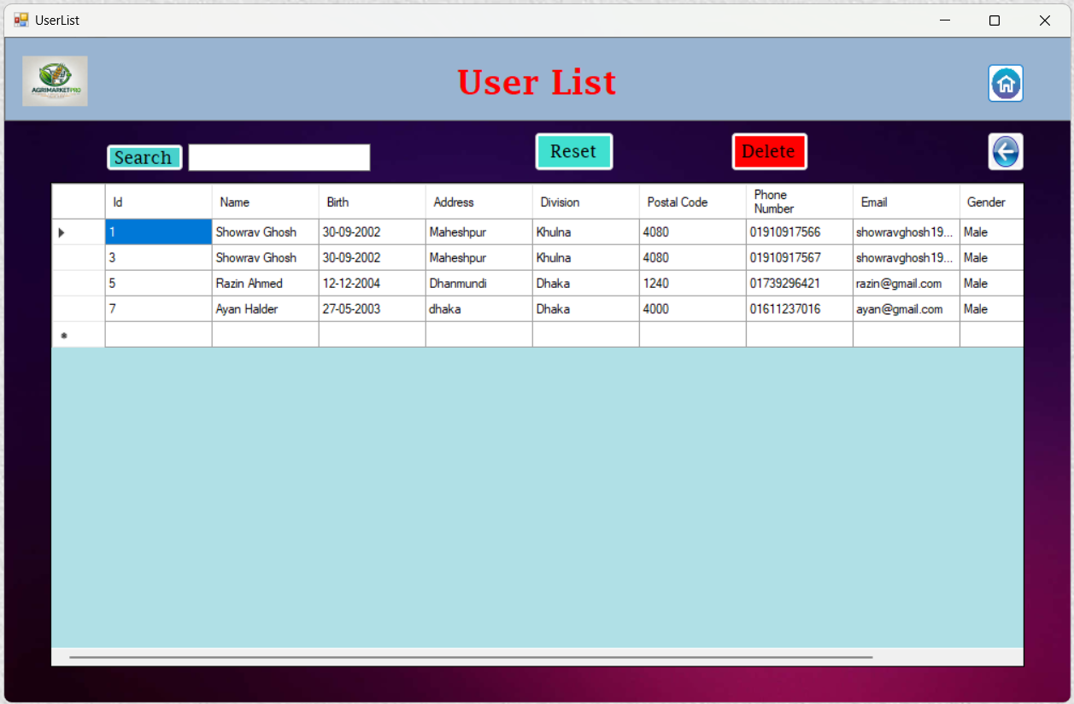

Delete User from the table.

Go for Log-in Frame

Back previous frame

For search User from the table.

Blank the search box.

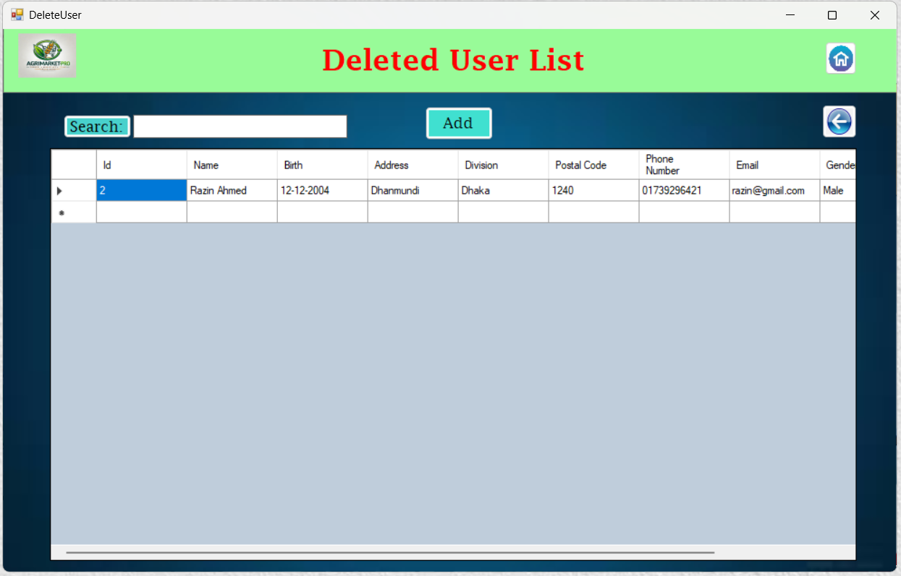

For search deleted farmer from the table.

Add again in the Farmer list table from this

Table.

Back previous frame

Go for Log-in Frame

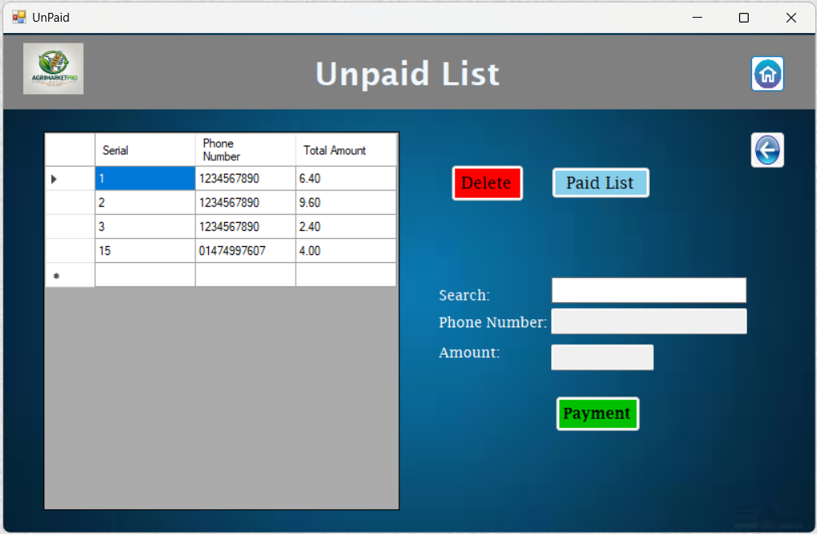

For make payment and pay to farmer.

Search unpaid farmer phone number.

Back previous frame

Go for Log-in Frame

See all the paid farmer transaction list.

Delete for cancel request.

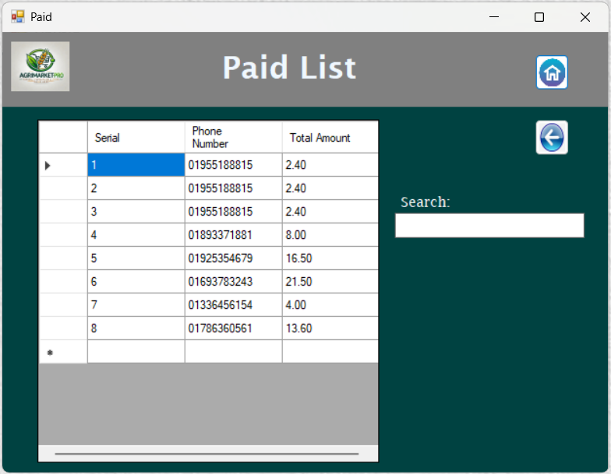

Search by number to get any paid farmer data from the table.

Back previous frame

Go for Log-in Frame

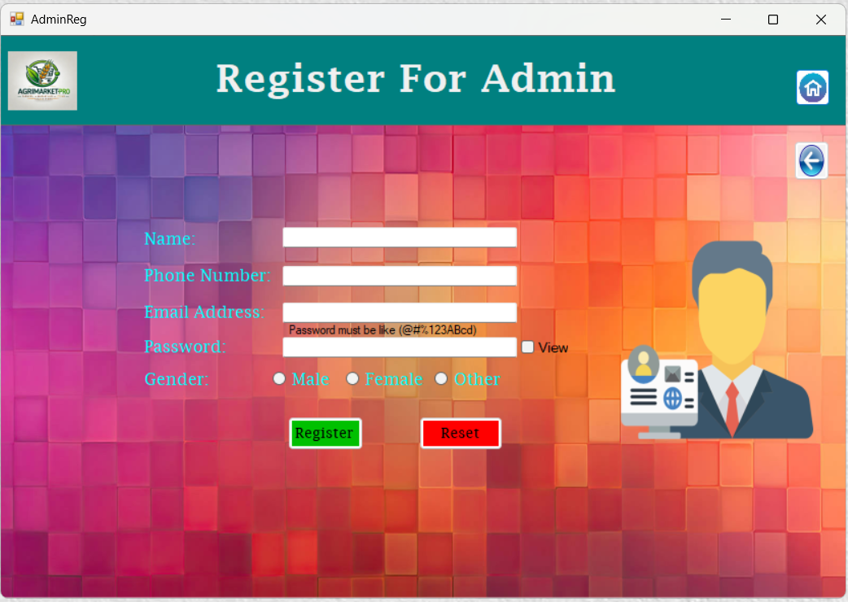

Back previous frame

Go for Log-in Frame

show password

Register for new Admin.

Remove all selected thing and textbox.

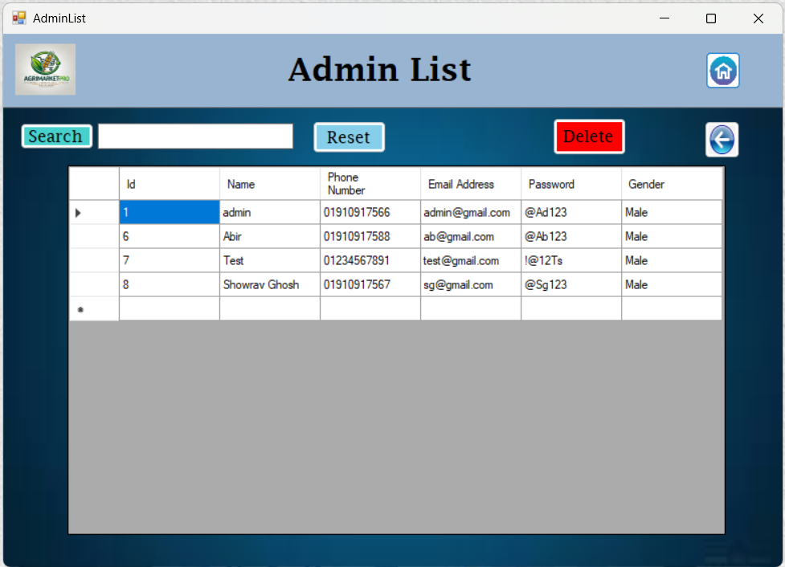

Remove text from search box.

Delete Admin from the list.

Search Admin from the list

Back previous frame

Go for Log-in Frame

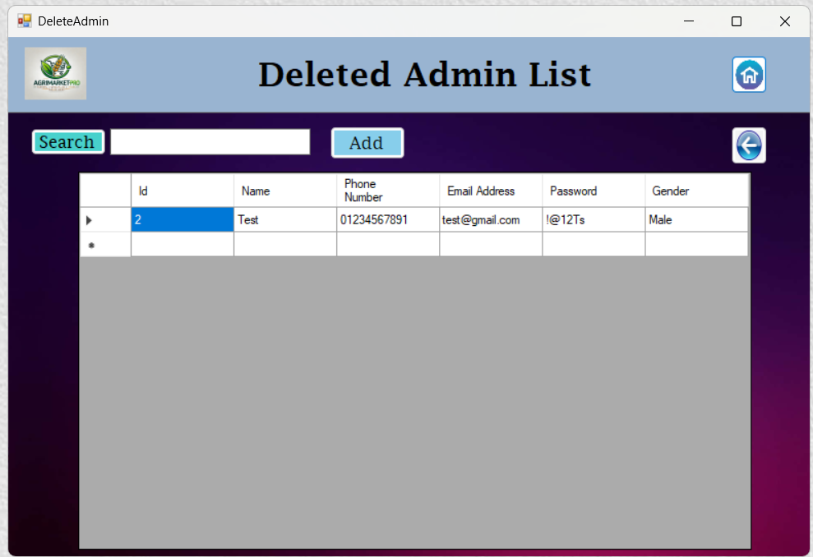

Go for Log-in Frame

Back previous frame

Add again in the Admin list table from this

Table.

For search deleted Admin from the table.

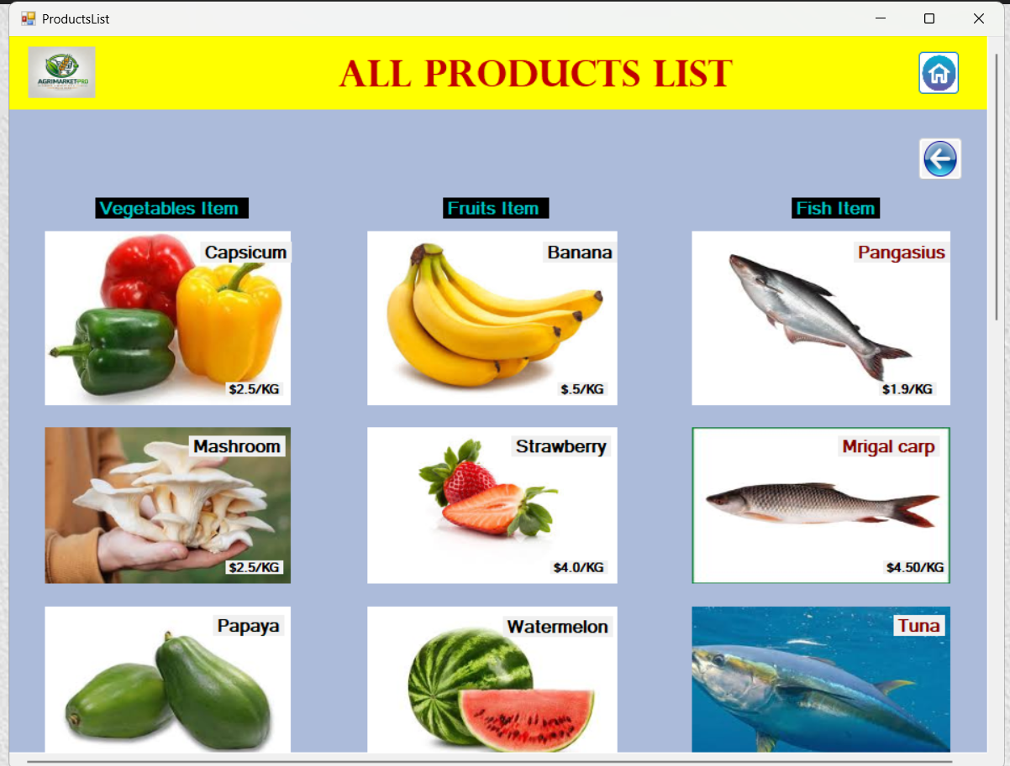

Up down for see more product from this list.

Back previous frame

Go for Log-in Frame

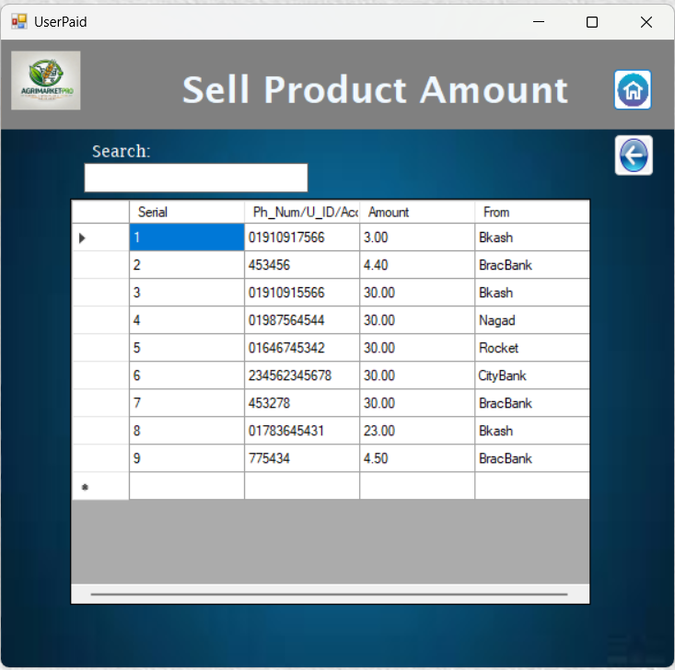

Search by number for dee all the transaction that made by user from the table.

Back previous frame

Go for Log-in Frame